A Farm Segmentation Analysis  
for Agricultural Priority Setting Purposes  
at The Bill and Melinda Gates Foundation

# The Problem

Effectively targeting agricultural development investments is extremely challenging due to the variation in constraints, opportunities, and implementing environments that exist across and within farming systems.

Farming systems are spatially diverse as they are strongly conditioned by local agro-climatic conditions and access to markets, both of which vary widely over space. There is also significant variation in the farming and livelihood strategies of individual households within farming systems. This household variation is conditioned by the socio-economic characteristics of local communities and individual households, such as the distribution of land and other assets, access to nonfarm employment, cultural values, and the dynamics of family lifecycles.

To manage this variation and provide a basis for targeting interventions to the needs of specific types of households requires a ‘segmentation’ or ‘typology’ analysis.

# An Approach to Segmenting

The segmentation approach outlined in this note is tailored to the needs of the Bill and Melinda Gates Foundation. The Foundation has established goals for what it wants to achieve (agricultural productivity growth, increased value to farmers, poverty reduction, improved nutrition outcomes, etc.) and areas of competence for its own interventions in agriculture (R&D, access to inputs, value chain development for prioritized commodities, etc.). To segment on all these criteria is impractical, so a two-step approach is taken here. In the first step farms are segmented on variables that reflect the competencies of the Foundation and its potential to make a significant difference in each segment. The second step is then to screen the selected segments to help identify those segments that rank the highest against the Foundation’s goals. Identifying these high priority segments, and having a view into the unique characteristics of farmers in those segments, should help the Foundation achieve maximize impact and achieve its goals.

# Step 1: Segmenting on Key Indicators

This segmentation groups farmers according to three variables that are highly relevant to the foundation’s work: farming system, agricultural potential, and market access.

## Farming System

Segmenting by farming system helps identify groups of farms that grow the same major commodities and face similar technology and management constraints, and hence who are likely to have similar research/technology needs and priorities. Farming systems can be defined on the basis of the major commodities grown. Alternatively, standard farming system typologies, such as those developed by FAO, can be used. The commodity based approach has intuitive appeal for value chain approaches but the downside is that commodity mixes may not be robust over time because farmers adjust their growing decision over time according to changes in prices, weather shocks, climate change, etc. The farming systems approach has the advantage that it respects the biological integrity of each farming system in terms of its soil, water and pest management, and unlike definitions based on dominant commodities, is more likely to be robust over time

## Agricultural Potential

The highest returns to research and other productivity enhancing investments are likely to be achieved if they are targeted to regions where there is remaining agricultural potential to exploit. For this segmentation we have decided to use a measure of yield gap as opposed to using a measure of biophysical potential. This is because it takes into account what is already being achieved in addition to what is possible. There are many ways to measure this gap, including the difference between the average yield of the top 10% of farmers and the regional average, or between crop model simulated yields and the average. In the case of multiple products, the gap could be calculated as the difference between the total revenue/ha that is possible versus the average revenue/ha observed. Where detailed data are available on all farm outputs and inputs, then the average level of profit might be calculated, and compared with the maximum profit attainable in a region given its endowments of fixed factors and agro-climatic conditions. The latter can be measured through a production function approach.

## Market Access

Market access is typically measured using the average distance to a market center, sometimes taking account of the types of roads and transport to be used by converting distances into time estimates.

After defining appropriate measures of each of the three segmenting variables, intervals for each variable are defined to arrive at a finite number of segments. For example, if there are two farming systems, and if agricultural potential and market access are both split into high and low categories, then this would lead to a total of 8 segments: Farming System 1, high potential, high market access (S1HH); S1HL; … S2LL.

# Step 2: Identifying and Characterizing Potential High Priority Segments

Once step 1 has been completed, the next step is to identify and characterize potential high priority segments according to foundation goals. For example, one of the goals is to increase agricultural productivity, so segments with the highest productivity gaps and greatest access to markets would be attractive targets. Since the foundation has already identified priority commodities for its own work, then this would suggest prioritizing segments with farming systems in which those commodities are important. These choices can be made using the outputs from step 1.

But the Foundation also has a number of other social goals, including helping poor and women farmers, improving diets, and reducing food insecurity, so segments might also need to be prioritized against these goals. Where the data exists then the analyst can characterize the typical or average farm household in each segment for key variables like size of holding, gender of household head, incidence of poverty, etc. and these attributes can be included when decision makers are prioritizing the segments from step 1. Where sample sizes allow, it is also possible to explore some of the variability within each segment and to identify subgroups of households that might warrant special attention.

Given multiple goals, a difficulty quickly arises in that choices have to be made. If different segments score highly on different goals, then one may end up with too many prioritized segments to be useful. In some cases segments may score highly on some goals but low on others, in which case tradeoff choices have to be made. It has to be recognized that the segmentation approach developed here is not a decision making tool, but merely seeks to develop and present pertinent information in ways that can help inform decisions by foundation staff.

# Illustrative Results for Ethiopia

To illustrate the approach, Figure 5 shows the results of overlaying the three segmenting variables (farming system, agricultural potential, and market access) for Ethiopia. There are six major farming systems in Ethiopia and by using high and low intervals for agricultural potential and market access, 20 representative segments are obtained (Table 12).

For this example the segmenting variables are defined in the following three sections. As a general rule we measure how much of the variability across farm households is explained through each of the segmenting variables to decide whether the selected variable is useful or not (see Table 6 below showing the variance explained through FAO farming systems).

## Farming Systems

Farming systems are derived from Garrity, Dennis, Dixon, John and Boffa, Jean-Marc (2012) “*Understanding African Farming Systems: Science and Policy Implications.*” Sydney, Australia. Australian Centre for International Agricultural Research[1].

Figure 1: Farming Systems, Ethiopia (Dixon et al, 2012)

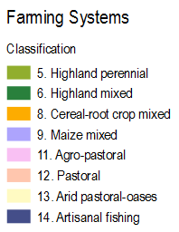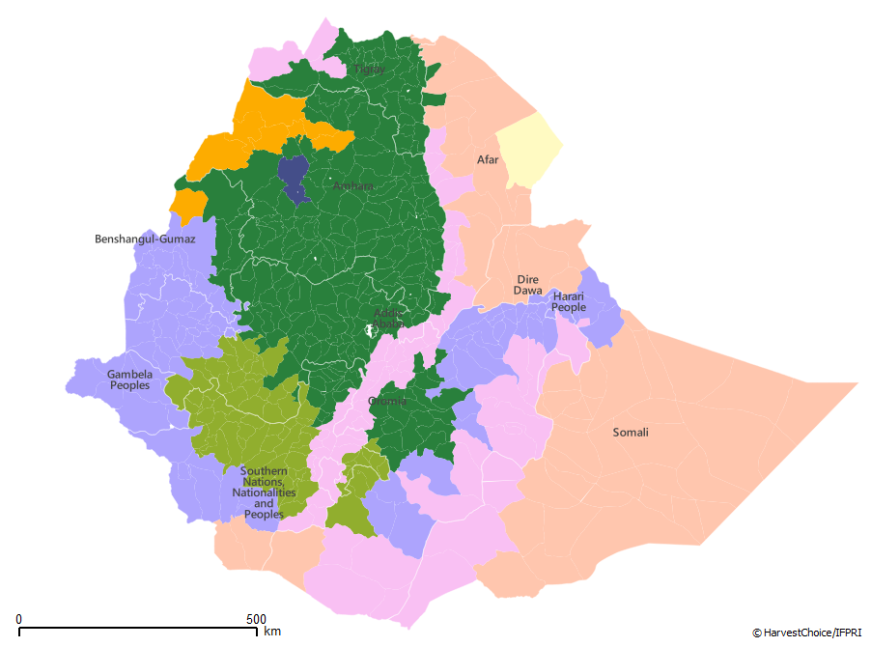

In the most recent release Dixon et al. identify thirteen systems for Africa based on a combination of biophysical variables (water, land, grazing areas, forest, length of growing period and altitude) and household livelihood characteristics (dominant agricultural productions and intensification level). Eight of these farming systems are found in Ethiopia, of which two (arid pastoral-oases and artisanal fishing) represent very little land area and population (we choose to discard them in the remaining classification).

Table 1: Distribution of Farming Systems, Ethiopia

|  |  |  |  |  |
| --- | --- | --- | --- | --- |
| Farming System | Total Area (share) | Harvested Area (share) | Time to Market (hrs) | Yield Gap  (int. $/ha) |
| Highland perennial | 7% | 14% | 8 | 1,117 |
| Highland mixed | 25% | 61% | 6 | 1,003 |
| Cereal-root crop mix | 3% | 2% | 7 | 965 |
| Maize mixed | 17% | 13% | 8 | 859 |
| Agro-pastoral | 15% | 8% | 6 | 2,995 |
| Pastoral | 32% | 0% | 9 | 715 |
| Arid pastoral-oases | 1% | 0% | 6 | n/a |
| Artisanal fishing | 0% | 0% | 2 | 1,254 |

Table 2: Population and Poverty Prevalence across Farming Systems, Ethiopia

|  |  |  |  |
| --- | --- | --- | --- |
| Farming System | ’05 Rural Population (share) | ’05 Urban Population (share) | Rural Poverty HCR ($1.25/day) |
| Highland perennial | 17% | 10% | 39% |
| Highland mixed | 54% | 60% | 39% |
| Cereal-root crop mix | 2% | 3% | 39% |
| Maize mixed | 14% | 11% | 33% |
| Agro-pastoral | 11% | 12% | 38% |
| Pastoral | 1% | 3% | 44% |
| Arid pastoral-oases | 0% | 0% | 43% |
| Artisanal fishing | 0% | 1% | 40% |

Sources: HarvestChoice/IFPRI, 2014

Table 3: Selected Demographic Indicators across Farming Systems, Ethiopia (2011)

|  |  |  |  |  |
| --- | --- | --- | --- | --- |
| Farming System | Age  (years) | Education (years) | Household Size | Adult  Dependency Ratio |
| Highland Perennial | 43.06 | 2.02 | 5.29 | 1.42 |
| Highland Mixed | 45.20 | 2.13 | 4.89 | 1.20 |
| Cereal/Root Crop | 41.83 | 1.50 | 5.08 | 1.12 |
| Maize Mixed | 44.38 | 2.04 | 5.43 | 1.43 |
| Agro-pastoral | 45.01 | 2.43 | 5.85 | 1.43 |
| Pastoral | 42.64 | 1.19 | 4.84 | 1.28 |

Sources: Authors, Ethiopia ERSS, 2011.

Table 4: Non-Farm Income in Total Household Income across Farming Systems, Ethiopia (2011)

|  |  |
| --- | --- |
| Farming System | Percent |
| Highland Perennial | 24.26 |
| Highland Mixed | 34.01 |
| Cereal/Root Crop | 37.45 |
| Maize Mixed | 27.51 |
| Agro-pastoral | 23.25 |
| Pastoral | 31.97 |

Sources: Authors, Ethiopia ERSS, 2011.

Table 5: Selected Food Security Indicators across Farming Systems, Ethiopia (2011)

|  |  |  |  |
| --- | --- | --- | --- |
| Farming System | Household worries about food (share) | Average Number of Meals (adults/day) | Average Number of Meals (kids/day) |
| Highland Perennial | 36.17 | 2.79 | 3.33 |
| Highland Mixed | 42.67 | 2.75 | 3.48 |
| Cereal/Root Crop | 2.15 | 2.94 | 3.96 |
| Maize Mixed | 6.65 | 2.78 | 3.42 |
| Agro-pastoral | 12.26 | 2.76 | 3.90 |
| Pastoral | 0.1 | 2.85 | 3.45 |

Sources: Authors, Ethiopia ERSS, 2011.

Figure 2: Farm Technical Efficiency across Farming Systems, Ethiopia (2011)



Sources: Authors, Ethiopia ERSS, 2011 (exclude outside values).

Note: Technical efficiency is a measure of performance of farmers against the most efficient farmers. Efficient farmers are those whose input use yields the maximum possible output in light of the current technology. Efficiencies range from zero to one.

Table 6: Explained Variance of Selected Variables when Controlling for FAO Farming Systems (2011)

|  |  |
| --- | --- |
| Variable | Percent |
| Total value of production | 14% |
| Elevation - best predictor of potential | 56% |
| Technical efficiency | 10% |
| Income | 7% |

Sources: Authors, Ethiopia ERSS, 2011.

Given its natural terrain Ethiopia's landscape exhibits strong biophysical heterogeneity, such that many agronomists comment that Dixon’s systems are not necessarily best suited to represent Ethiopia’s complex natural base and livelihood patterns. We anticipate developing a revised farming system delineation to address this concern.

## Market Access

The source for Ethiopia’s market access zones is HarvestChoice, 2014. “*Travel time to nearest town over 50K (median, hours, 2000)*”. International Food Policy Research Institute, Washington, DC, and University of Minnesota, St. Paul, MN. Available on-line at <http://harvestchoice.org/maps/TT_50K>.

For Ethiopia we define low (high) market access for areas further (closer) than *4hrs to the nearest 50K town*[2].

Figure 3: Travel Time to Nearest 50K Town across Kebeles, Ethiopia (median, hours, 2000)

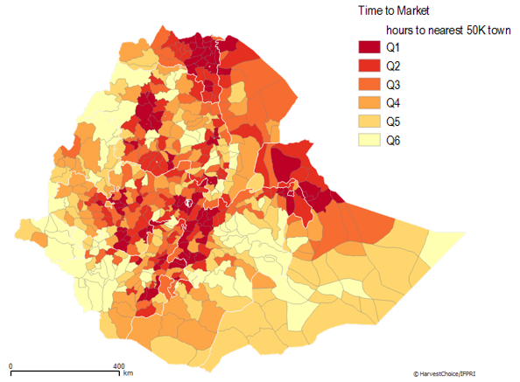

Table 7: Distribution of High/Low Market Access Zones, Ethiopia

|  |  |  |  |  |
| --- | --- | --- | --- | --- |
| Market Access | Total Area (share) | Harvested Area (share) | Time to Market (hrs) | Yield Gap (int. $/ha) |
| Low | 91% | 80% | 8 | 952 |
| High | 9% | 20% | 3 | 2,408 |

Table 8: Population and Poverty Prevalence across High/Low Market Access Zones, Ethiopia

|  |  |  |  |
| --- | --- | --- | --- |
| Market Access | ’05 Rural Population (share) | ’05 Urban Population (share) | Rural Poverty ($1.25/day) |
| Low | 79% | 37% | 38% |
| High | 21% | 63% | 39% |

Sources: HarvestChoice/IFPRI, 2014

## Agricultural Potentials

In this illustration we estimate agricultural potentials based on a measure of aggregate yield gaps. The gap is measured as the wedge between actual and potential yields (for both rain-fed and irrigated systems) in kg/ha for each of 42 commodity groups. We then construct an aggregate yield gap in value terms. Potential yield are derived from GAEZ 2009[3]. Actual yields are from IFPRI SPAM 2005[4]. Figure 4 shows low-to-high agricultural potentials across Kebeles.

Figure 4: Aggregate Yield Gap across Kebeles, Ethiopia (low to high quantiles, int. $/ha, 2005)

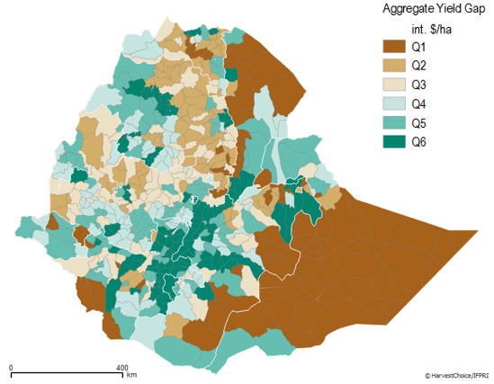

In the case of Ethiopia we then define low (high) yield gaps for Kebeles with aggregate yield gap *below (above) 500$/ha* (this corresponds to the median yield gap value across all Kebeles). The mean value is at $1,090/ha.

Table 9: Distribution of High/Low Agricultural Potential Zones, Ethiopia

|  |  |  |  |  |
| --- | --- | --- | --- | --- |
| Yield Gap | Total Area  (share) | Harvested Area (share) | Time to Market (hrs) | Yield Gap  (int. $/ha) |
| Low | 36% | 48% | 7 | 291 |
| High | 39% | 52% | 6 | 1927 |
| Undefined | 25% | 0% | 11 | n/a |

Table 10: Population and Poverty Prevalence across High/Low Agricultural Potential Zones, Ethiopia

|  |  |  |  |
| --- | --- | --- | --- |
| Yield Gap | ’05 Rural Population (share) | ’05 Urban Population (share) | Rural Poverty ($1.25/day) |
| Low | 45% | 22% | 38% |
| High | 54% | 68% | 38% |
| Undefined | 2% | 10% | 40% |

Sources: HarvestChoice/IFPRI, 2014.

## Preliminary Results

Table 12 through Table 13 show the distribution of the resulting 22 segments. Table 14 through Table 20 show some of the characteristics of the average household in each of the segments.

The 22 segments are labelled as shown in Table 11, with segments 9 and 20 representing very little land area and population.

Figure 5: Segmenting by Area of Competence – Spatial Distribution of Segments, Ethiopia

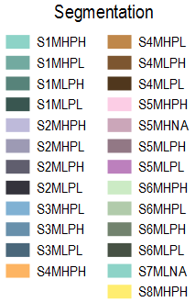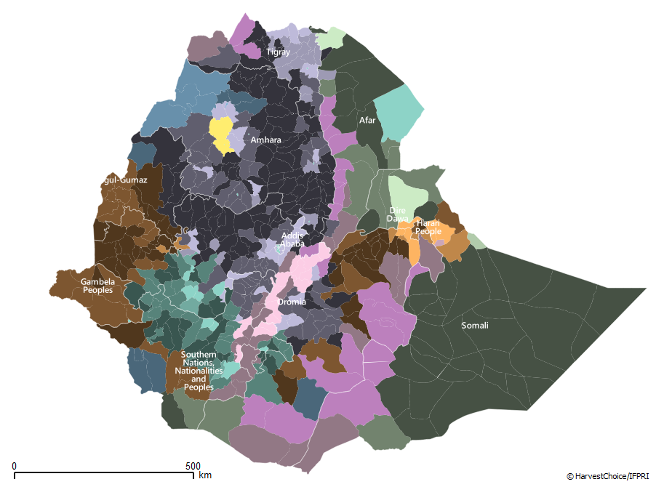

Table 11: Segmenting by Area of Competence – Ethiopia’s 22 Segments

|  |  |  |  |  |
| --- | --- | --- | --- | --- |
| # | Farming System | Market  Access | Agricultural  Potential | Segment |
| 1 | Highland perennial | high | high | S1MHPH |
| 2 | Highland perennial | high | low | S1MHPL |
| 3 | Highland perennial | low | high | S1MLPH |
| 4 | Highland perennial | low | low | S1MLPL |
| 5 | Highland mixed | high | high | S2MHPH |
| 6 | Highland mixed | high | low | S2MHPL |
| 7 | Highland mixed | low | high | S2MLPH |
| 8 | Highland mixed | low | low | S2MLPL |
| 9 | Cereal-root crop | high | low | S3MHPL |
| 10 | Cereal-root crop | low | high | S3MLPH |
| 11 | Cereal-root crop | low | low | S3MLPL |
| 12 | Maize mixed | high | high | S4MHPH |
| 13 | Maize mixed | high | low | S4MHPL |
| 14 | Maize mixed | low | high | S4MLPH |
| 15 | Maize mixed | low | low | S4MLPL |
| 16 | Agro-pastoral | high | high | S5MHPH |
| 17 | Agro-pastoral | low | high | S5MLPH |
| 18 | Agro-pastoral | low | low | S5MLPL |
| 19 | Pastoral | high | high | S6MHPH |
| 20 | Pastoral | high | low | S6MHPL |
| 21 | Pastoral | low | high | S6MLPH |
| 22 | Pastoral | low | low | S6MLPL |

Table 12: Distribution and Characterization of Segments, Ethiopia

|  |  |  |  |  |
| --- | --- | --- | --- | --- |
| Segment | Total Area (share) | Harvested Area (share) | Time to Market (hrs) | Yield Gap  (int. $/ha) |
| S1MHPH | 1% | 1% | 3.5 | 2,231 |
| S1MHPL | 0% | 1% | 3.7 | 429 |
| S1MLPH | 4% | 6% | 9.5 | 1,585 |
| S1MLPL | 2% | 5% | 8.1 | 350 |
| S2MHPH | 2% | 8% | 3.1 | 2,329 |
| S2MHPL | 2% | 4% | 3.2 | 202 |
| S2MLPH | 8% | 21% | 6.5 | 1,341 |
| S2MLPL | 13% | 27% | 7.9 | 277 |
| S3MHPL | 0% | 0% | 0.8 | 61 |
| S3MLPH | 2% | 1% | 12.7 | 2,004 |
| S3MLPL | 1% | 1% | 6.6 | 217 |
| S4MHPH | 1% | 1% | 2.8 | 4,776 |
| S4MHPL | 1% | 1% | 3.0 | 192 |
| S4MLPH | 7% | 5% | 8.7 | 926 |
| S4MLPL | 6% | 8% | 8.9 | 306 |
| S5MHPH | 1% | 4% | 2.9 | 3,984 |
| S5MLPH | 7% | 4% | 7.4 | 2,767 |
| S5MLPL | 3% | 2% | 6.8 | 287 |
| S6MHPH | 1% | 0% | 3.6 | 815 |
| S6MHPL | 0% | 0% | 2.9 | - |
| S6MLPH | 5% | 0% | 7.2 | 899 |
| S6MLPL | 8% | 0% | 10.2 | 132 |

Sources: HarvestChoice/IFPRI, 2014.

Table 13: Population and Poverty Prevalence across Segments, Ethiopia

|  |  |  |  |
| --- | --- | --- | --- |
| Segment | ’05 Rural Population  (share) | ’05 Urban Population  (share) | Rural Poverty  ($1.25/day) |
| S1MHPH | 2% | 3% | 37% |
| S1MHPL | 1% | 0% | 35% |
| S1MLPH | 10% | 4% | 39% |
| S1MLPL | 5% | 1% | 38% |
| S2MHPH | 6% | 28% | 38% |
| S2MHPL | 4% | 7% | 45% |
| S2MLPH | 19% | 11% | 39% |
| S2MLPL | 23% | 8% | 38% |
| S3MHPL | 0% | 2% | 40% |
| S3MLPH | 1% | 0% | 40% |
| S3MLPL | 1% | 0% | 40% |
| S4MHPH | 1% | 4% | 37% |
| S4MHPL | 1% | 2% | 32% |
| S4MLPH | 4% | 3% | 35% |
| S4MLPL | 8% | 2% | 33% |
| S5MHPH | 5% | 10% | 37% |
| S5MLPH | 5% | 3% | 38% |
| S5MLPL | 1% | 0% | 41% |
| S6MHPH | 0% | 0% | 45% |
| S6MHPL | 0% | 0% | 48% |
| S6MLPH | 0% | 1% | 41% |
| S6MLPL | 0% | 1% | 49% |

Sources: HarvestChoice/IFPRI, 2014.

Table 15: Percent of Female-headed Households across Segments, Ethiopia (2011)

|  |  |  |  |
| --- | --- | --- | --- |
| **Farming System** | **Yield Potential** | **Market Potential** | Percent of female headed households |
| **Agro-pastoral** | **H** | **H** | 1.23 |
| **L** | 2.43 |
| **L** | **H** | 0.59 |
| **L** | 6.54 |
| **Pastoral** | **L** | **H** | 0.26 |
| **L** | 3.34 |
| **Highland Perennial** | **H** | **H** | 2.07 |
| **L** | 0.89 |
| **L** | **H** | 1.81 |
| **L** | 12.66 |
| **Highland Mixed** | **H** | **H** | 1.53 |
| **L** | 1.23 |
| **L** | **H** | 8.42 |
| **L** | 33.83 |
| **Cereal/Root Crop Mixed** | **H** | **H** | 0.31 |
| **L** | **L** | 1.17 |
| **Maize Mixed** | **H** | **H** | 6.05 |
| **L** | **H** | 2.25 |
| **L** | 13.4 |

Sources: Authors, Ethiopia ERSS, 2011.

Table 16: Technical Efficiency and Non-Farm Income across Segments, Ethiopia (2011)

|  |  |  |  |
| --- | --- | --- | --- |
| **Farming System** | **Yield Potential** | **Market Potential** | **Technical efficiency** |
| **Agro-pastoral** | **H** | **H** | 0.47 |
| **L** | 0.2 |
| **L** | **H** | 0.14 |
| **L** | 0.15 |
| **Pastoral** | **L** | **H** | . |
| **L** | 0.04 |
| **Highland Perennial** | **H** | **H** | 0.1 |
| **L** | 0.09 |
| **L** | **H** | 0.14 |
| **L** | 0.16 |
| **Highland Mixed** | **H** | **H** | 0.34 |
| **L** | 0.11 |
| **L** | **H** | 0.19 |
| **L** | 0.22 |
| **Cereal/Root Crop Mixed** | **H** | **H** | 0.04 |
| **L** | **L** | 0.33 |
| **Maize Mixed** | **H** | **H** | 0.18 |
| **L** | **H** | 0.23 |
| **L** | 0.18 |

Sources: Authors, Ethiopia ERSS, 2011.

Figure 6: Variation in Technical Efficiency across Segments, Ethiopia (2011)

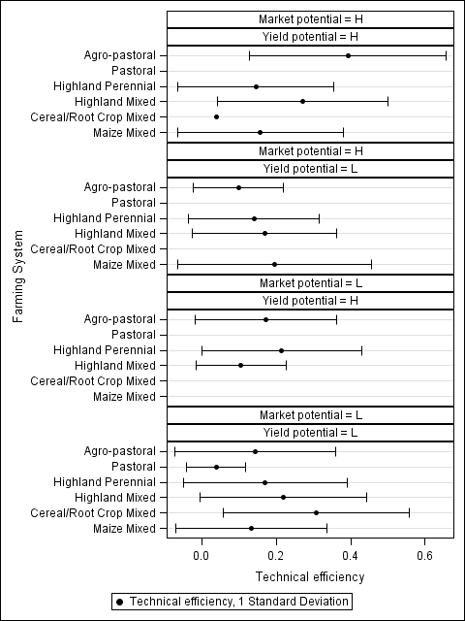

Note: This graph shows the average the average technical efficiency of each system (black dot) and one standard deviation to each side of the average. This figure illustrates the variability in technical efficiency within each of the farming systems for each combination of yield and market potential.

Table 18: Selected Food Security Indicators across Segments, Ethiopia (2011)

|  |  |  |  |
| --- | --- | --- | --- |
| **Farming System** | **Yield Potential** | **Market Potential** | **Concerns about food (%)** |
| **Agro-pastoral** | **H** | **H** | 1.21 |
| **L** | 2.44 |
| **L** | **H** | 0.59 |
| **L** | 6.51 |
| **Pastoral** | **L** | **H** | 0.23 |
| **L** | 3.33 |
| **Highland Perennial** | **H** | **H** | 2.08 |
| **L** | 0.9 |
| **L** | **H** | 1.82 |
| **L** | 12.64 |
| **Highland Mixed** | **H** | **H** | 1.54 |
| **L** | 1.23 |
| **L** | **H** | 8.46 |
| **L** | 33.85 |
| **Cereal/Root Crop Mixed** | **H** | **H** | 0.31 |
| **L** | **L** | 1.18 |
| **Maize Mixed** | **H** | **H** | 6.05 |
| **L** | **H** | 2.21 |
| **L** | 13.41 |

# Country Briefs

The segmentation analysis will lead to country briefs that summarize key decision information as succinctly as possible. The proposed content is as follows:

* Methodology
* Map of segments
* Table and figures showing the characteristics of each segment (disaggregated by gender whenever feasible):
  + population size (individuals and farms)
  + population density
  + poverty rate
  + average farm size
  + average household size and composition
  + gender variables
  + main crop and livestock productions
  + technical efficiency
  + consumption patterns
  + input use
  + income sources
  + risk exposure
  + etc.
* Identification of subgroups of interest based on analysis of household variability within segments
* Suggested ranking of segments and subgroups against Foundation goals and key choices/tradeoffs to be considered, to be summarized in a table.
* Analysis of the kinds of interventions that would make most sense for each of the priory segments and subgroups.

Table xx: Shares of household crop production used for consumption and sales and average cultivated land.

|  |  |  |  |  |  |  |  |  |
| --- | --- | --- | --- | --- | --- | --- | --- | --- |
|  | | | **Proportion** | **Proportion** | **Cultivated Land (ha)** | **Proportion** | **Proportion** | **Cultivated Land (ha)** |
| **of crop** | **of crop** |  | **of crop** | **of crop** |  |
| **used for** | **used for** |  | **used for** | **used for** |  |
| **consumption** | **sale** |  | **consumption** | **sale** |  |
| **Barley** | **Barley** | **Barley** | **Maize** | **Maize** | **Maize** |
| **Average share** | **Average share** | **Average (ha)** | **Average share** | **Average share** | **Average (ha)** |
| **Farming System** | **Yield Potential** | **Market Potential** |  |  |  |  |  |  |
| **Agro-pastoral** | **H** | **H** | 85.57 | 0 | 0.83 | 81.44 | 12.75 | 0.83 |
| **L** | 42.52 | 44.52 | 0.82 | 84.25 | 1.26 | 0.82 |
| **L** | **H** | . | . | 0.38 | 88.14 | 5.3 | 0.38 |
| **L** | 33 | 0 | 1.01 | 82.36 | 6.14 | 1.01 |
| **Pastoral** | **L** | **H** | . | . | . | . | . | . |
| **L** | . | . | 5.52 | 85.69 | 4.93 | 5.52 |
| **Highland Perennial** | **H** | **H** | 74.57 | 2.74 | 0.41 | 71.47 | 7.02 | 0.41 |
| **L** | 50.01 | 46.65 | 0.25 | 91.49 | 7.17 | 0.25 |
| **L** | **H** | 63.04 | 5.39 | 0.91 | 83.2 | 5.52 | 0.91 |
| **L** | 61.59 | 17.75 | 0.8 | 74.23 | 14.63 | 0.8 |
| **Highland Mixed** | **H** | **H** | 64.8 | 11.05 | 1.67 | 58 | 3.69 | 1.67 |
| **L** | 70.68 | 0 | 1.42 | 68.19 | 0 | 1.42 |
| **L** | **H** | 79.44 | 3.63 | 0.88 | 86.75 | 3.12 | 0.88 |
| **L** | 68.17 | 7.44 | 1.85 | 73.93 | 14.16 | 1.85 |
| **Cereal/Root Crop Mixed** | **H** | **H** | . | . | 0 | . | . | 0 |
| **L** | **L** | . | . | 2.28 | 85.71 | 6.58 | 2.28 |
| **Maize Mixed** | **H** | **H** | 99.91 | 0 | 0.92 | 86.55 | 0.05 | 0.92 |
| **L** | **H** | 70.04 | 0 | 0.83 | 80.79 | 4.06 | 0.83 |
| **L** | 75.08 | 5.31 | 1.21 | 78.21 | 5.8 | 1.21 |
|  |  |  |  |  |  |  |  |  |

|  |  |  |  |  |  |  |  |  |
| --- | --- | --- | --- | --- | --- | --- | --- | --- |
|  |  |  |  |  |  |  |  |  |
|  |  |  |  |  |  |  |  |  |
|  | | | **Proportion** | **Proportion** | **Cultivated Land (ha)** | **Proportion** | **Proportion** | **Cultivated Land (ha)** |
| **of crop** | **of crop** |  | **of crop** | **of crop** |  |
| **used for** | **used for** |  | **used for** | **used for** |  |
| **consumption** | **sale** |  | **consumption** | **sale** |  |
| **Rice** | **Rice** | **Rice** | **Sorghum** | **Sorghum** | **Sorghum** |
| **Average share** | **Average share** | **Average (ha)** | **Average share** | **Average share** | **Average (ha)** |
| **Farming System** | **Yield Potential** | **Market Potential** |  |  |  |  |  |  |
| **Agro-pastoral** | **H** | **H** | . | . | 0.83 | 86.25 | 0 | 0.83 |
| **L** | . | . | 0.82 | 91.56 | 3.71 | 0.82 |
| **L** | **H** | . | . | 0.38 | 91.56 | 0 | 0.38 |
| **L** | . | . | 1.01 | 75.25 | 5.38 | 1.01 |
| **Pastoral** | **L** | **H** | . | . | . | . | . | . |
| **L** | . | . | 5.52 | . | . | 5.52 |
| **Highland Perennial** | **H** | **H** | . | . | 0.41 | 74.55 | 13.33 | 0.41 |
| **L** | . | . | 0.25 | 69.44 | 11.11 | 0.25 |
| **L** | **H** | . | . | 0.91 | 74.04 | 8.02 | 0.91 |
| **L** | . | . | 0.8 | 72.39 | 12.45 | 0.8 |
| **Highland Mixed** | **H** | **H** | . | . | 1.67 | . | . | 1.67 |
| **L** | 75.71 | 14.29 | 1.42 | 77.99 | 3.9 | 1.42 |
| **L** | **H** | . | . | 0.88 | 85.15 | 3.11 | 0.88 |
| **L** | 55.31 | 23.01 | 1.85 | 77.66 | 10.16 | 1.85 |
| **Cereal/Root Crop Mixed** | **H** | **H** | . | . | 0 | . | . | 0 |
| **L** | **L** | 95 | 0 | 2.28 | 74.45 | 8.44 | 2.28 |
| **Maize Mixed** | **H** | **H** | . | . | 0.92 | 87.22 | 0 | 0.92 |
| **L** | **H** | 80 | 20 | 0.83 | 83.98 | 7.67 | 0.83 |
| **L** | 94.1 | 0.9 | 1.21 | 84.87 | 3.32 | 1.21 |
|  |  |  |  |  |  |  |  |  |
|  |  |  |  |  |  |  |  |  |

|  |  |  |  |  |  |  |  |  |
| --- | --- | --- | --- | --- | --- | --- | --- | --- |
|  |  |  |  |  |  |  |  |  |
|  |  |  |  |  |  |  |  |  |
|  | | | **Proportion** | **Proportion** | **Cultivated Land (ha)** | **Proportion** | **Proportion** | **Cultivated Land (ha)** |
| **of crop** | **of crop** |  | **of crop** | **of crop** |  |
| **used for** | **used for** |  | **used for** | **used for** |  |
| **consumption** | **sale** |  | **consumption** | **sale** |  |
| **Teff** | **Teff** | **Teff** | **Wheat** | **Wheat** | **Wheat** |
| **Average share** | **Average share** | **Average (ha)** | **Average share** | **Average share** | **Average (ha)** |
| **Farming System** | **Yield Potential** | **Market Potential** |  |  |  |  |  |  |
| **Agro-pastoral** | **H** | **H** | 57.86 | 32.14 | 0.83 | 31.67 | 51.67 | 0.83 |
| **L** | 26.34 | 60.31 | 0.82 | 33.68 | 57.62 | 0.82 |
| **L** | **H** | 10 | 90 | 0.38 | 91.67 | 0 | 0.38 |
| **L** | 46.92 | 26.54 | 1.01 | 37.05 | 35.03 | 1.01 |
| **Pastoral** | **L** | **H** | . | . | . | . | . | . |
| **L** | . | . | 5.52 | . | . | 5.52 |
| **Highland Perennial** | **H** | **H** | 27.25 | 47.45 | 0.41 | 60.17 | 12.17 | 0.41 |
| **L** | 48.7 | 40.42 | 0.25 | 100 | 0 | 0.25 |
| **L** | **H** | 61.33 | 15.09 | 0.91 | 58.64 | 14.75 | 0.91 |
| **L** | 62.14 | 19.6 | 0.8 | 53.58 | 25.23 | 0.8 |
| **Highland Mixed** | **H** | **H** | 63.17 | 14.51 | 1.67 | 61.18 | 12.06 | 1.67 |
| **L** | 78.07 | 1.53 | 1.42 | 84.82 | 1.14 | 1.42 |
| **L** | **H** | 69.12 | 14.96 | 0.88 | 66.15 | 11.74 | 0.88 |
| **L** | 61.85 | 21.17 | 1.85 | 62.52 | 11.41 | 1.85 |
| **Cereal/Root Crop Mixed** | **H** | **H** | . | . | 0 | . | . | 0 |
| **L** | **L** | 86.37 | 1.32 | 2.28 | 85 | 0 | 2.28 |
| **Maize Mixed** | **H** | **H** | . | . | 0.92 | 83.46 | 0 | 0.92 |
| **L** | **H** | . | . | 0.83 | 65.45 | 4.82 | 0.83 |
| **L** | 81.12 | 3.89 | 1.21 | 74.88 | 5.78 | 1.21 |
|  |  |  |  |  |  |  |  |  |

|  |  |  |  |  |  |  |  |  |
| --- | --- | --- | --- | --- | --- | --- | --- | --- |
|  |  |  |  |  |  |  |  |  |
|  |  |  |  |  |  |  |  |  |
|  | | | **Proportion** | **Proportion** | **Cultivated Land (ha)** | **Proportion** | **Proportion** | **Cultivated Land (ha)** |
| **of crop** | **of crop** |  | **of crop** | **of crop** |  |
| **used for** | **used for** |  | **used for** | **used for** |  |
| **consumption** | **sale** |  | **consumption** | **sale** |  |
| **Oats** | **Oats** | **Oats** | **Millet** | **Millet** | **Millet** |
| **Average share** | **Average share** | **Average (ha)** | **Average share** | **Average share** | **Average (ha)** |
| **Farming System** | **Yield Potential** | **Market Potential** |  |  |  |  |  |  |
| **Agro-pastoral** | **H** | **H** | . | . | 0.83 | 85 | 0 | 0.83 |
| **L** | . | . | 0.82 | 95.75 | 0 | 0.82 |
| **L** | **H** | . | . | 0.38 | . | . | 0.38 |
| **L** | . | . | 1.01 | 65.44 | 15.53 | 1.01 |
| **Pastoral** | **L** | **H** | . | . | . | . | . | . |
| **L** | . | . | 5.52 | . | . | 5.52 |
| **Highland Perennial** | **H** | **H** | . | . | 0.41 | . | . | 0.41 |
| **L** | . | . | 0.25 | . | . | 0.25 |
| **L** | **H** | 92.27 | 0 | 0.91 | 74.67 | 5.13 | 0.91 |
| **L** | . | . | 0.8 | 58.28 | 0.75 | 0.8 |
| **Highland Mixed** | **H** | **H** | 100 | 0 | 1.67 | . | . | 1.67 |
| **L** | . | . | 1.42 | 85.14 | 0.34 | 1.42 |
| **L** | **H** | 50 | 30 | 0.88 | 72.89 | 9.54 | 0.88 |
| **L** | 63.88 | 8.73 | 1.85 | 72.51 | 11.92 | 1.85 |
| **Cereal/Root Crop Mixed** | **H** | **H** | . | . | 0 | . | . | 0 |
| **L** | **L** | . | . | 2.28 | 77.27 | 9.81 | 2.28 |
| **Maize Mixed** | **H** | **H** | . | . | 0.92 | . | . | 0.92 |
| **L** | **H** | 30 | 22.5 | 0.83 | . | . | 0.83 |
| **L** | 90 | 0 | 1.21 | 81.63 | 1.65 | 1.21 |
|  |  |  |  |  |  |  |  |  |

|  |  |  |  |  |  |  |  |  |
| --- | --- | --- | --- | --- | --- | --- | --- | --- |
|  |  |  |  |  |  |  |  |  |
|  |  |  |  |  |  |  |  |  |
|  | | | **Proportion** | **Proportion** | **Cultivated Land (ha)** |  |  |  |
| **of crop** | **of crop** |  |  |  |  |
| **used for** | **used for** |  |  |  |  |
| **consumption** | **sale** |  |  |  |  |
| **Coffee** | **Coffee** | **Coffee** |  |  |  |
| **Average share** | **Average share** | **Average (ha)** |  |  |  |
| **Farming System** | **Yield Potential** | **Market Potential** |  |  |  |  |  |  |
| **Agro-pastoral** | **H** | **H** |  |  | 0.83 |  |  |  |
| **L** | . | . | 0.82 |  |  |  |
| **L** | **H** | . | . | 0.38 |  |  |  |
| **L** | 3.27 | 94.05 | 1.01 |  |  |  |
| **Pastoral** | **L** | **H** | . | . | . |  |  |  |
| **L** | . | . | 5.52 |  |  |  |
| **Highland Perennial** | **H** | **H** | . | . | 0.41 |  |  |  |
| **L** | . | . | 0.25 |  |  |  |
| **L** | **H** | 25.71 | 57.14 | 0.91 |  |  |  |
| **L** | . | . | 0.8 |  |  |  |
| **Highland Mixed** | **H** | **H** | . | . | 1.67 |  |  |  |
| **L** | . | . | 1.42 |  |  |  |
| **L** | **H** | . | . | 0.88 |  |  |  |
| **L** | 26.42 | 60.09 | 1.85 |  |  |  |
| **Cereal/Root Crop Mixed** | **H** | **H** | . | . | 0 |  |  |  |
| **L** | **L** | 10.36 | 81.43 | 2.28 |  |  |  |
| **Maize Mixed** | **H** | **H** | 97.46 | 0 | 0.92 |  |  |  |
| **L** | **H** | . | . | 0.83 |  |  |  |
| **L** | 33.72 | 41.05 | 1.21 |  |  |  |

Note: Dots indicate that production does not take place in the given farming system.

1. Available on-line at <http://aciar.gov.au/aifsc/sites/default/files/images/understanding_african_farming_systems_11_dec_update.pdf>
2. The time to market measure is further documented at <http://harvestchoice.org/labs/travel-time-major-market-cities>.
3. GAEZ model documentation and data is available at <http://www.fao.org/nr/gaez/en/>.
4. SPAM documentation at <http://mapspam.info/>.